Product Requirements Document - Studi Buddi

1. Goals

Our goals for this project are to develop a mobile app in android for students to freely share what they need to study for or receive help on, connect with other students to study for material they both struggle with, and schedule study meetings between two to many students to allow them to give/receive help and expand their network. Our application Studi Buddi aims to create a welcoming environment for students to ask questions to other people that have the same struggles. The current process of finding someone to study with implies that there is physical interaction or that there is an established relationship with others. However with StudiBuddi that relationship can be melded easily through our social media like environment.

2. User Personas

User persona 1: Justina Pickle

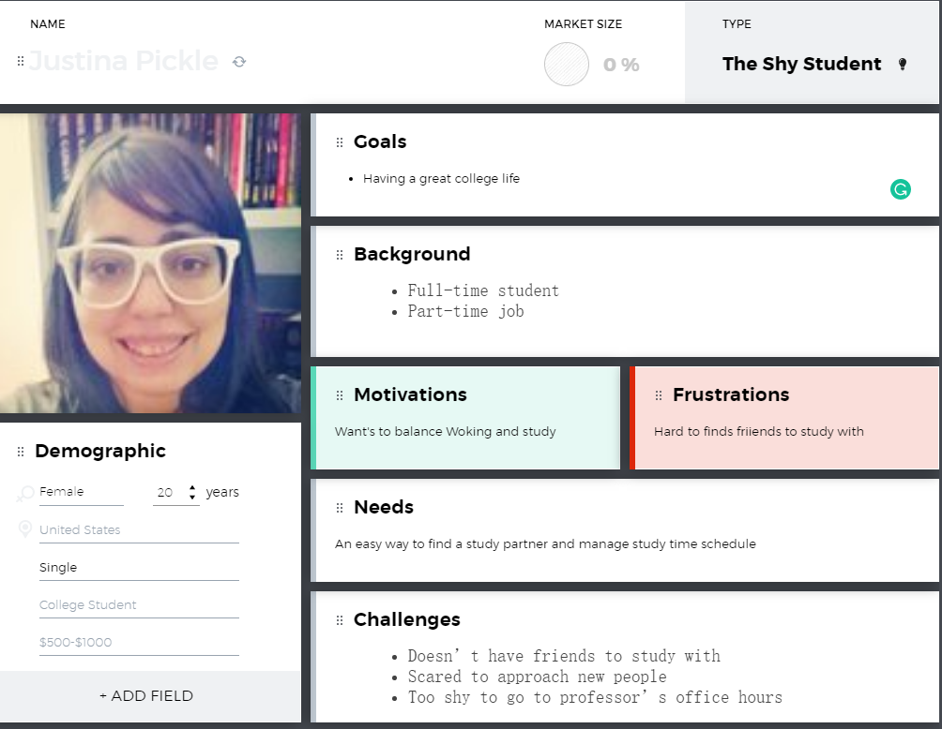

User persona 2: Sean Curly

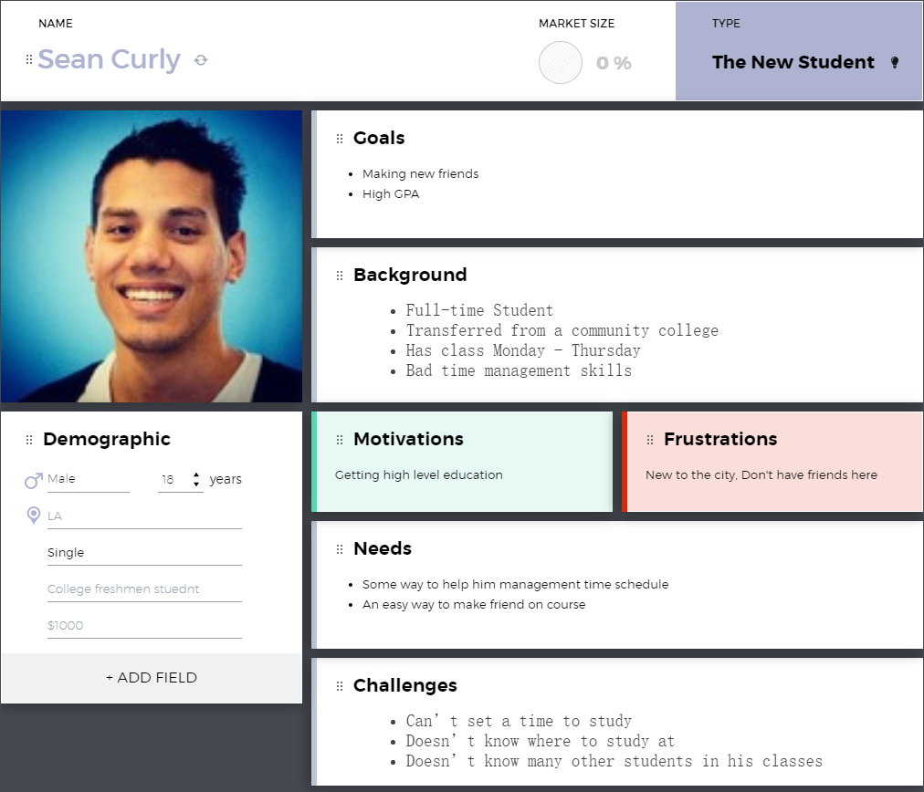

User persona 3: Admin

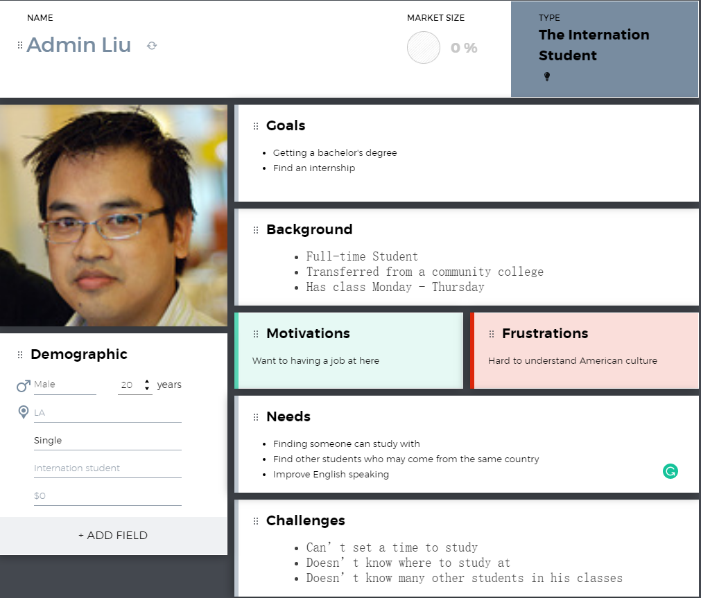

3. User Stories

|  |  |  |  |  |
| --- | --- | --- | --- | --- |
| # | Title | Description | Priority | Notes |
| 1 | Login page | A user wants to login to the application | Must have | A page allow user enter user id and login to application |
| 2 | Sign up page | A user wants to make an account for the application | Must have | The sign up page needs to have validation for their email. |
| 3 | Edit profile page | A user wants to edit their profile picture, description about themselves | Should have | The user needs to have the correct info displayed. |
| 4 | User Profile Screen | A user can view another user’s profile with all the details. | Must have | List all user information |
| 5 | Home Screen | A user can view the home screen of the application. Which allows them to create posts, filter posts, etc. | Must have | Show all the function menu of the Application and wate user choice |
| 6 | Activity | A user can interact with the application such as having conversations with other users. | Must have | Message exchange |
| 7 | Study locations | A user can select their study location, and they can also see recommended study locations. | Must have | Show user location by GPS |
| 8 | Study tracker page | A user can see their history of study sessions with other people. | Should have | Show the list of study information |
| 9 | Settings | A user can change settings within the application. | Must have | User can modify the App |
| 10 | Review study session | A user can review previous study sessions that they had with other people. | Should have | User can review what they had learn |
| 11 | Schedule study session | A user can schedule study sessions with other people. | Must have | Match other user’s schedule together |
| 12 | Create post | A user can create a post by inserting a title of the post with the title of the class, subject, and description of the request | Must have | Allow user post information on the board |
| 13 | Studi sessions | A user can view all scheduled studi sessions. A user can rate, and look at previous studi sessions | Must have | Self-study group |
| 14 | General post details | A user can view the details, comment, and create a new studi session from the post | Must have | Check self-study group and change the setting |
| 15 | Studi session details | A user can see the details of a studi session, and can join a studi session | Should have | Show all the session information |
| 16 | Buddi list | A user can see a list of all their buddi’s and select a user to view their profile | Should have | Show user’s friends list and detail information |
| 17 | Chat between users | A user wants to chat with another person through the application | Should have | Sending messages to one another |
| 18 | Filter posts | A user can filter posts depending on which class, and topic they are struggling in | Must have | For picking a specific class to get tutoring |
| 19 | Log out | A user can log out of the application. | Must have | If a user wants to logout of the applicaiton |
| 20 | Pick different backgrounds | A user can pick different backgrounds of the application to see which one they like best. | Not required | If a user wants to tailor the application to their liking. |
| 21 | Setting profile to private | A user wants to set their profile to private. | Should have | A user does not want anyone to view their profile. |
| 22 | Adding friends | A user wants to add another user to their friend list | Must have | This is for users that want to easily message the other user. |
| 23 | Block users | A user wants to block another user | Must have | For people that do not want to be messaged by a specific person |
| 24 | Private studi sessions | A user can make their studi sessions private or friend only | Must have | They want only specific users to join their session. |
| 25 | Public studi sessions | A user can make their studi sessions public so anyone can join their session | Must have | Anyone can join the session. |
| 26 | Inviting other users | A user can invite another user to a studi session | Must have | A user can get invited to join a session |
| 27 | Request to join | A user can request to join a studi session | Must have | The user does not always have to be invited. |
| 28 | View current sessions | A user can view any current public sessions for a class, subject, then topic | Must have | If a user wants to view all the current sessions being held. |
| 29 | Upload profile picture | A user can upload a profile picture onto their profile | Should have | A use editing their profile |
| 30 | Set status to busy | A user can set themselves to busy to prevent additional invitations from other users. | Should have | Checks to see if user is in multiple studi sessions. |
| 31 | Signing up with email | A user can sign up with their student email | Must have | Need to check if the email is valid |
| 32 | Entering a password | A user can enter their password on the signup page | Must have | A password is required for an account. |
| 33 | Enter phone number | A user can enter their phone number to be associated with their account | Optional | A phone number is optional. |
| 34 | Sign up button | A user can confirm their information with the sign up button | Must have | None |
| 35 | Setting school | A user can set which school they attend | Must have | Check to have a list of schools. |
| 36 | Pick current classes | A user can set which classes they are currently enrolled in | Must have | None |
| 37 | Set major | A user can set their major | Must have | None |
| 38 | Set free time | A user can set their free times to allow recommended study sessions during that time | Must have | None |
| 39 | Create a studi session | A user can create a studi session | Must have | Make sure they are not in any other sessions |
| 40 | View conversations | A user can view different conversations with other users | Must have | None |
| 41 | Accepting a studi session | A user can accept a studi session invite from other users | Must have | None |
| 41 | Declining a studi session | A user can decline a studi session invite from other users | Must have | None |
| 42 | Rate studi buddi | A user can rate other users if they have had a studi session together. | Must have | None |
| 43 | Time availability for locations | A user can see if a location is open at a specific time | Must have | None |
| 44 | Resource availability for location | A user can see if the location has any study resources available. | Must have | None |
| 45 | Future Study Sessions | A user can see future study sessions that they have available. | Must have | None |
| 46 | Duration of study session | A user can view how long they had a studi session | Must have | None |
| 47 | Class/subject studied | A user can view which class/subject they studied for. | Must have | None |
| 48 | Adjust notification settings | A user can adjust how they get notifications | Must have | None |
| 49 | Set time for studi session | A user can set a time for their studi session | Must have | None |
| 50 | Set subject for studi session | A user can set a subject for their studi session | Must have | None |

4. Server Sitemap

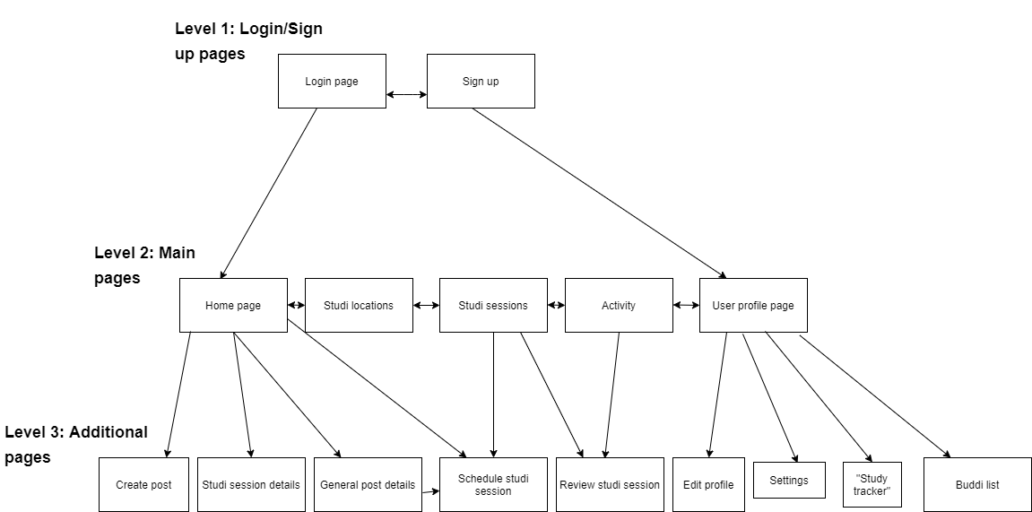

5. Page Description

|  |  |
| --- | --- |
| **Page** | **Elements** |
| Login page | 1. Colored themed page with Studi Buddi logo 2. Text box to enter email address or username 3. Text box to enter password 4. Button to login 5. Button to sign up |
| Sign up page | 1. Colored themed page with Studi Buddi logo 2. Text box to enter email 3. Validate if email exists and is valid student email 4. Enter password box 5. Enter password again 6. Potentially enter phone number 7. Button to sign up 8. Button to go back to login page |
| Edit profile page (Will always pop up after new user signs up, but users can always come back) | 1. Set school 2. Pick current classes 3. Pick any current topics/subjects they want 4. Set additional profile details    1. Set studying preferences for their profile    2. Upload a profile photo    3. Set major or focus of study    4. Allow the user to set “busy” times to not schedule meetings during that time    5. Allow the user to set “free” times to recommend study sessions during that time |
| User Profile Screen (opens when a user clicks another user’s profile picture) | 1. Allows viewing of a user profile:    1. Profile Picture    2. Name    3. Favorite topics or top 5 classes/topics studied for recently    4. Current classes    5. Major    6. Top 5 buddis 2. Button to request study session 3. Button to chat with a user 4. Button to add as friend |
| Home Screen | 1. Overview of public posts and public sessions 2. Allows the user to create a new studi session 3. Allows the user to create a new public post 4. Allows the user to filter posts by topic or by class |
| Activity | 1. Shows your conversations with different users 2. Ability to open a conversation with a user and direct message them 3. Shows notifications received from other users and the application 4. Overview of recent activity the user has engaged in 5. Shows invites to studi sessions that the user can accept or decline 6. Shows invites to add a Buddi that the user can accept or decline 7. Shows a recommendation to review recent studi sessions and rate the other users, time, and location |
| Study locations | 1. Shows local recommended study spaces 2. Gives an overview of the location    1. Picture    2. Loud or quiet    3. Food available    4. Time availability    5. Resources available |
| Study tracker page | 1. Shows past sessions you have completed    1. Date    2. Time    3. How long you studied    4. Who you studied with    5. What class/subject you studied 2. Shows future planned study sessions 3. Shows machine learning recommended study sessions for you    1. Ability to accept or decline these machine learning recommendations 4. Show other statistics |
| Settings | 1. Users will be able to edit app settings such as notifications and preferences |
| Review study session | 1. Users can review completed sessions on multiple criteria    1. Location    2. User studied with (if applicable)    3. Time    4. Subject 2. A user performing these will add to our machine learning data to recommend user-favored locations, subjects to study, and buddis to study with |
| Schedule study session | 1. Creates a study session and the user can set parameters to their liking    1. Time    2. Location    3. Who it’s with    4. Public or private    5. Subject |
| Create post | 1. Enter title of post    1. Class related to post    2. Topic related to class 2. Option to enter detailed description of request for help in a particular class and topic |
| Studi sessions | 1. User can view all sessions they are scheduled for in a chronological ordered scrollable list view 2. User can view previous studi sessions 3. User can rate previous studi sessions 4. User can add studi session to Google Calendar 5. User can create another studi session |
| General post details | 1. Shows the user the details 2. Comment section where other users can comment on that post 3. Can create a new studi session from the details of the post |
| Studi session details | 1. Shows the user the details of the studi session 2. Other users can comment on the session if public or if already invited to it 3. Can join the studi session |
| Buddi list | 1. Lists all of a user’s “buddis” aka friends list 2. Select user to view their profile 3. A user can request a studi session with one of their buddis they have added |

6. Wireframes

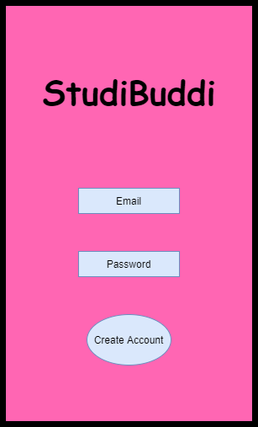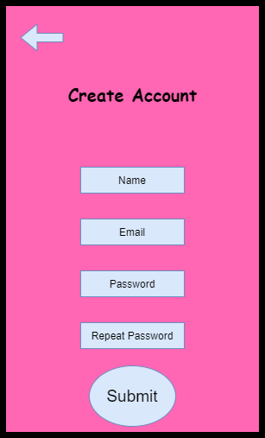

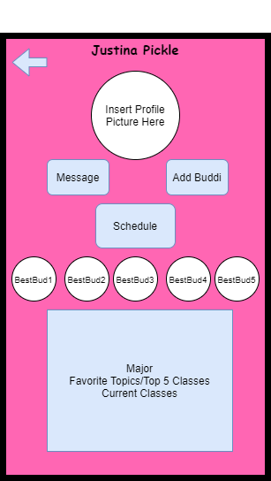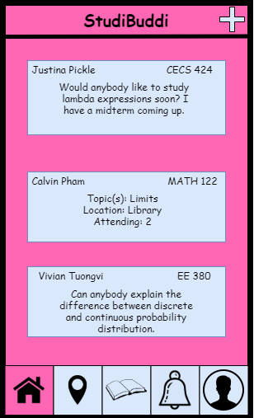

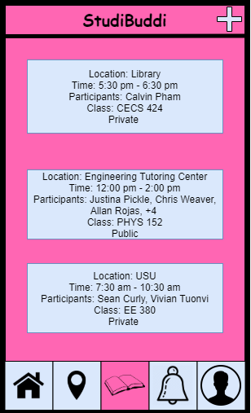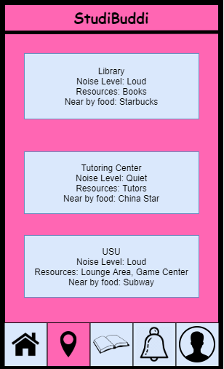

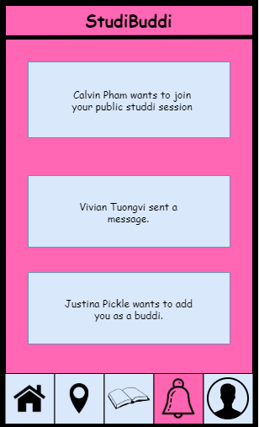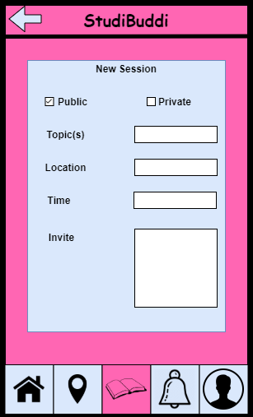

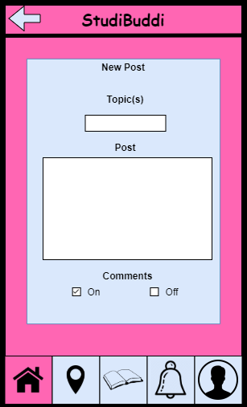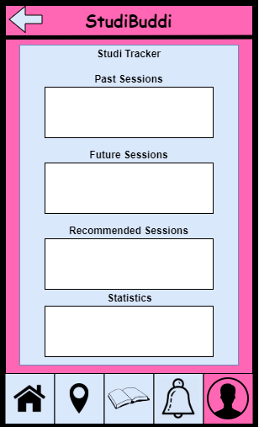

7. Interfaces

|  |  |  |  |  |
| --- | --- | --- | --- | --- |
| # | Interface | Description | Priority | Notes |
| 1 | Users | A standard user of our app | High | A user will have basic access to primary features |
| 2 | Admin | Our team of software owners as admins will have additional features and authority to execute additional commands within the app | High | An admin will have all functionality of a user plus administrative powers within the app |
| 3 | Java JDBC | Provides universal data access from Java onto a database server | High | We will use this to interface between our app and our database to store, collect, and use data for the users, home feed, and machine learning data |
| 4 | J2OBJC | An open-source command-line tool to port our android code to iOS | Medium | We will use this to make our app cross-platform on iOS in order to reach a larger user base and allow our class to test it on their phones |
| 5 | Email Validator API | An API that will allow us to verify a user’s email address as valid | Medium | We will use this to verify that our user has entered a correct and active email address |
| 6 | Google Calendar API | An API to display, create, and modify calendar events | High | We will use this API to schedule study sessions for the user and allow users to display this in their google calendar |

8. Additional Functional Requirements

|  |  |  |  |
| --- | --- | --- | --- |
|  | Additional Functional requirements | Description | Priority |
| 1 | Database | We need to use a database to keep track of user information. | Must have |
| 2 | UI Design | The UI should be easy to use and user friendly. | Should have |
| 3 | Server | A server has to be running for users to use the application. | Must have |

9. Non - Functional Requirements

|  |  |  |  |
| --- | --- | --- | --- |
| # | Non - Functional Requirements | Description | Priority |
| 1 | Reliability | Ensure whenever the user uses the application, it is responsive and does anything the user wants it to do. | Must have |
| 2 | Maintainability | This application should be easy to update. | Must have |
| 3 | Portability | This is a phone application. Users will be able to access Studibuddi as long as they have their phone | Must have |
| 4 | Scalability | There will not be many users when the application is prototyped because it will use the CECS department for its testing. However when other departments at CSULB are integrated, the amount of users will increase. | Must have |
| 5 | Availability | Studibuddi will be available for users as long as the servers are online. | Should have |
| 6 | Data Integrity | Maintain a strong emphasis on protecting the user’s data | Must have |

10. Performance Requirements

|  |  |  |
| --- | --- | --- |
| # | Performance Requirements | Description |
| 1 | Loading time for application startup | The loading time for starting up the application should not take more than 20 seconds |
| 2 | On click | The response time for anything that needs to be tapped/clicked should not take no longer than 1-2 seconds. |
| 3 | Creating a studi session | Creating a session with another student should take only 1 second. |
| 4 | Creating a post | After creating a post, the post should take 2-3 seconds to upload. |
| 5 | Max users | The application should withstand 50 users concurrently without major lag. |
| 6 | Database Read-Write | Fetching or writing data to the Database should take no longer than 2-3 seconds as a background task |

11. Future Iterations

|  |  |  |  |  |
| --- | --- | --- | --- | --- |
| # | Title | Description | Priority | Notes |
| 1 | Generality | The App can be used on all mobile phones | High | Work both on Android and IOS |
| 2 | Safety | Ensure the user's security by verifying the user's identity with student ID or email in our database | Medium | If can, ask college to offer student ID or email for our database to confirm that the user is a student on their college campus |
| 3 | Safety | Ensure the user's security by allowing the user to share location and status to an  Emergency contact | High | Similar to Uber’s safety features to provide a sense of comfort to users meeting new studi buddies |
| 4 | Privacy | Ensure the user's privacy by Encrypting our database and using a salt password | High | For cyber security and privacy - prevent account hacking, data leaks, and offer more security |
| 5 | Accessibility | Ensure the user's Accessibility by listing more study locations by finding empty classroom | Medium | To allow users more locations to study and recommend |
|  |  |  |  |  |